**EVOLVING PERSPECTIVES FOR THE FUTURE OF ARTIFICIAL INTELLIGENCE**

**AI Global Revenues $ Billion**

|  |  |
| --- | --- |
| **Year** | **Market Size** |
| 2022 | 68.8 |
| 2024 | 112.3 |
| 2026 | 180.5 |

**Machine Learning Dominates the Technology Sphere**

|  |  |
| --- | --- |
| **Segment** | **% Share** |
| Machine Learning | 41.0 |
| Natural Language Processing | 26.8 |
| Computer Vision | 20.2 |
| Context Aware Computing | 12.0 |
| **Total** | **100.0** |

**Healthcare, the Fastest Growing Application Area (% CAGR 2020-2027)**

|  |  |
| --- | --- |
| **Segment** | **% Growth** |
| Advertising & Media | 19.7 |
| BFSI | 25.2 |
| Healthcare | 33.4 |
| Retail | 31.7 |
| Automotive & Transportation | 20.9 |
| Manufacturing | 29.1 |
| Agriculture | 19.1 |

**Intriguing Technology Facts**

*(Present the data according to sample image copied below)*

* 77% of modern devices use AI in some form or the other
* 85% of C-level executives believe AI as critical to drive growth objectives
* 8.9 billion AI-powered digital voice assistants will be in use worldwide by 2025, surpassing the global population
* 26.1% will be contributed by AI technology to China’s GDP by 2030, the highest in the world
* 14% rise in global GDP by 2030 will come exclusively by of AI-powered activities
* 35% growth in the automotive industry by 2026 will come from AI powered solutions

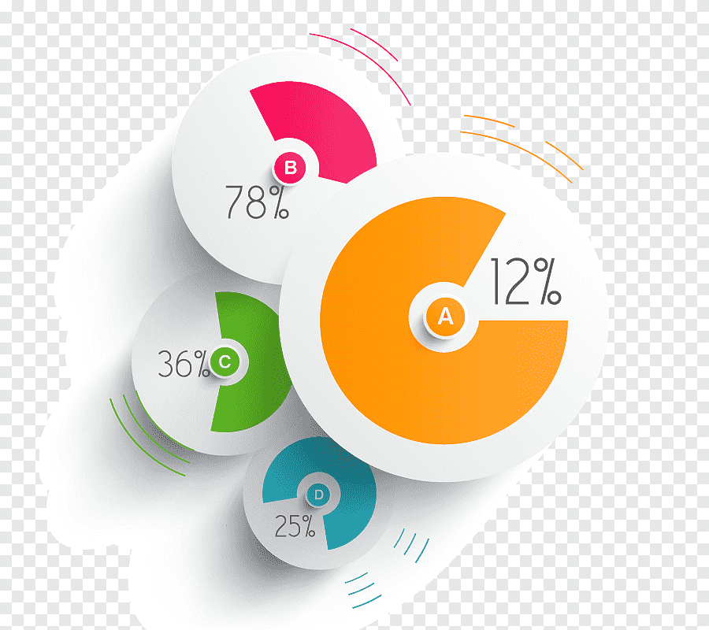

**Trending AI Business Trends**

*(Present the below information in the sample chart given below)*

This slide is 100% editable. Adapt it to your need and capture your audience’s attention

**Components**

**Staffing Process**

This slide is 100% editable. Adapt it to your need and capture your audience’s attention

**Text Here**

This slide is 100% editable. Adapt it to your need and capture your audience’s attention

**Text Here**

This slide is 100% editable. Adapt it to your need and capture your audience’s attention

**Text Here**

AI in manufacturing now ready for prime time



AI paves the way for faster commercialization of autonomous vehicles



AI use in predictive marketing & demand forecasting reaches mainstream



AI-powered biometric security solutions soon to gain momentum



AI regulations get more serious



A new era opens for AI powered robots



This slide is 100% editable. Adapt it to your need and capture your audience’s attention

**Components**

**Staffing Process**

This slide is 100% editable. Adapt it to your need and capture your audience’s attention

**Text Here**

This slide is 100% editable. Adapt it to your need and capture your audience’s attention

**Text Here**

This slide is 100% editable. Adapt it to your need and capture your audience’s attention

**Text Here**